THE 12 CORE SKILLS OF PHYSICAL LITERACY
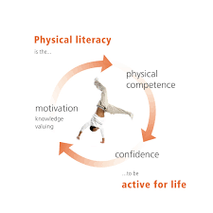
Posture
Balance
Squat
Landing
Jumping and Hopping
Skipping
Bounding
Rotation
Throwing
Catching and Dodging
Striking
Running

